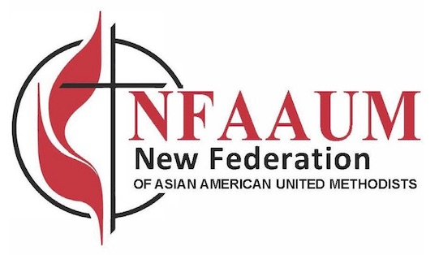

Press Release

Contact: Rev. Scort Christy [nfaaum@gmail.com](mailto:nfaaum@gmail.com)

March 8, 2021

**The National Federation of Asian American United Methodists officially became the New Federation of Asian American United Methodists (NFAAUM)**

**Who are we?**

NFAAUM is one of the five officially recognized racial ethnic caucuses of The United Methodist Church and seeks to empower and advocate on behalf of Asian American United Methodist laity, clergy, local congregations, and ministries at all levels of The United Methodist Church.  We represent the collective mission and ministry of the Cambodian, Chinese, Filipino, Formosan, Hmong, Indian, Japanese, Korean, Lao & Thai, Middle Eastern, Pakistani, and Vietnamese caucuses of the United Methodist Church.  [About Us | NFAAUM](https://www.nfaaum.org/about/)

The new Federation elected its new officers for 2020-2024: Rev. Scort Christy (President), Rev. Dr. Zaki Zaki (Vice President for Advocacy & Program), Rev. Edgar De Jesus (Vice President for Membership), Dr. Christina Lee (Secretary) and Rev. Tsuker Yang (Treasurer).

**Why do we exist?**

The creation of the New Federation is a result of much prayer and resolve on the part of the twelve Asian American United Methodist caucuses.

Working closely with denominational leadership and legal council, the new NFAAUM was incorporated on July 3, 2020 and subsequently adopted the same acronym, NFAAUM. During its first organizational meeting, a new Board of Directors was duly elected, and its new By-Laws approved. All original twelve Asian American Caucuses are represented in the new Board of Directors.  These are the Cambodian, Chinese, Filipino, Formosan, Hmong, Indian, Japanese, Korean, Lao & Thai, Middle Eastern, Pakistani, and Vietnamese caucuses.

**What is our mission?**

Our purpose is to emphasize on the linkages and the empowerment of the Asian American local churches of The United Methodist Church; to articulate the concerns, interest and needs of the Asian American constituencies in all levels of The United Methodist Church.

Rebirthed during a most turbulent and challenging time, the NFAAUM has immediately focused its attention on working collaboratively with AALM (Asian American Language Ministries), General Board of Church & Society and Global Ministries to develop a series of anti-racism webinars to engage and highlight Asian American voices and experiences regarding systemic racism and racial injustice.

By God’s grace and through the power of the Holy Spirit, NFAAUM is now ready to work for the full participation, empowerment, and advancement of our Asian American laity, clergy, congregations, ministries, and caucuses. To God be the glory!

New Federation of Asian American United Methodists (NFAAUM)

address:1401 Oak Ave. Evanston IL 60201

e-mail: [nfaaum@gmail.com](mailto:nfaaum@gmail.com)

website: <https://www.nfaaum.org>